1. Plot coil 1 and coil 2 before amplitude demodulation:

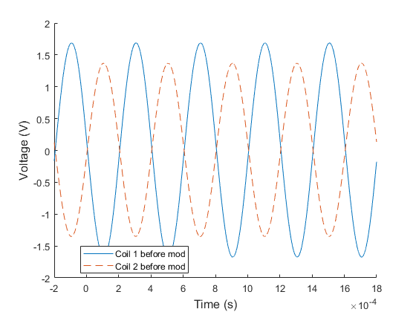

Figure : Coil 1 and coil 2 downward deflection output before demodulation

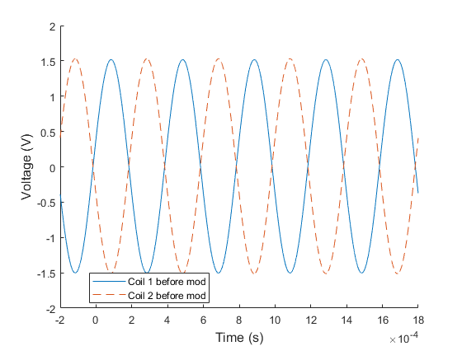

Figure : Coil 1 and coil 2 null output before demodulation

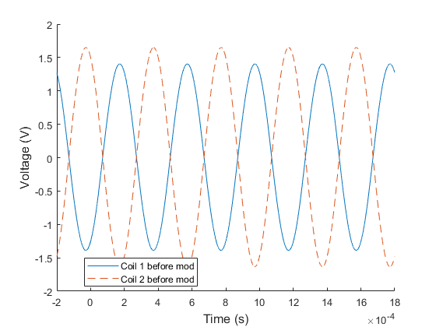

Figure : Coil 1 and coil 2 upward output before demodulation

Figure 1 shows the coil outputs when beam is deflected downwards; figure 2 shows the outputs when the beam is not deflected; and figure 3 shows the outputs when the beam is deflected upwards. When beam is deflected downwards, coil 1 output has a higher amplitude than coil 2, suggesting the metal core is closer to coil 1 than coil 2, which facilitates higher magnetic flux and induces more current in coil 1’s circuit. Similarly, when the beam is deflected upwards, the core is closer to coil 2, resulting in a higher output amplitude. Confirming to this, when the beam is not deflected, both coils’ outputs have the same amplitude.

1. A phase-sensitive demodulator extracted the modulation from the modulated coil signals using diode Wheatstone bridges. A modulated signal is one where the output is combined with a carrier wave to raise the signal to the detectable bandwidth range. Figure 4 shows the demodulated result of the coil’s output signals from the LVDT’s excitation signal of 10 V sine wave at 2.5 kHz.

The diodes block currents in the opposite direction. Therefore, demodulation will result in signals all on one side, as shown by the almost-M shaped signals for upwards and downwards deflections. The variations in the deflections as well as the no-deflection (null) state are results of the carrier frequency for the modulated signal.

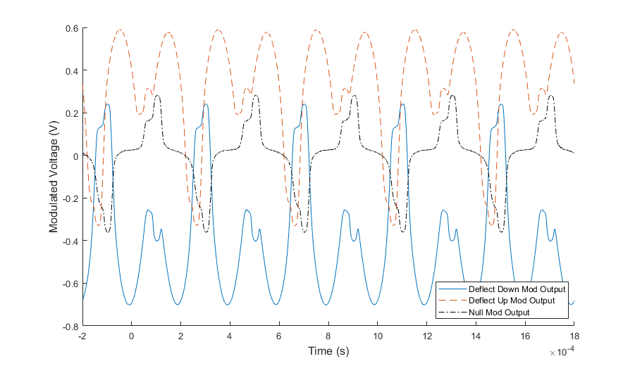

Figure : Amplitude modulated coil outputs at the three deflection conditions

1. The sensitive nature of the demodulation circuit calls for the need of a low-pass filter to remove the high frequency carrier wave in the output signal. This experiment used a RC circuit with a break frequency of 213 rad/s to act as the filter and the outputs are shown in Figure 5. It can be seen that when deflected upwards the output is positive, downwards is negative, and no deflection has an output of approximately zero.

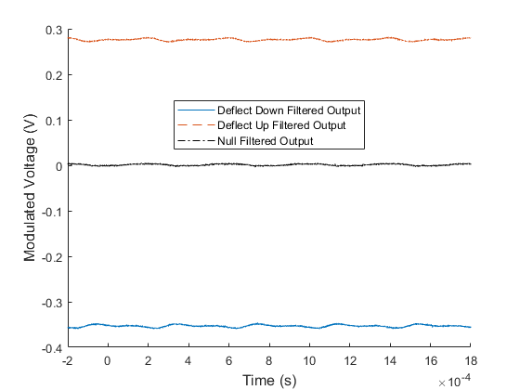

Figure : Demodulated signal after low-pass filter